**Increment 1**

**Budget Tracker**

**User Documentation**

**By Malik Johnson**

**Fall 2019**

Table of Contents

1. Purpose of Budget Tracker.
2. Create User.
3. Delete User.
4. Add Item.
5. Add Budget.
6. Create User table
7. Add Item table
8. Add Budget table

**Purpose of Budget Tracker**

Budget Tracker Allows you to track a budget through simple means. By creating a user you can create budgets for that user. You can also create items to add to that budget. This leads to the goal of displaying and maintain the budget in an easy manor.

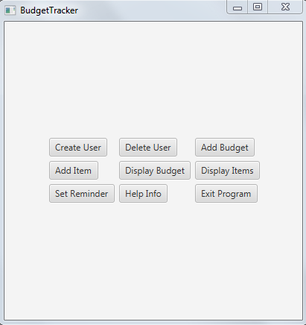

This is the user interface of Budget Tracker. For this increment only the Create User, Delete User, Add Budget, and Add Items buttons are functional. When you click on a button a new window is opening for input. The functions of each of the functional buttons will be covered below.

**Create User**

This is the user interface for the create user button.

You can create a username, password, first name, last name, budget amount, income amount, savings amount, number of bank accounts, and bank account total.

The submit button sends the data to the database for storage and clears the fields if there are no exceptions. The clear button clears all fields for easy clearing. The back button closes the window.

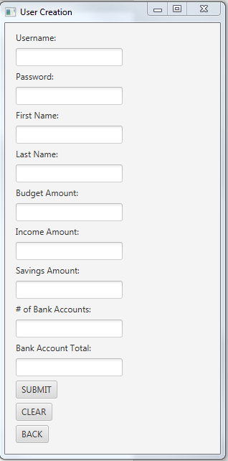

**Delete User**

This is the user interface for the delete user button.

This only requires the username and password of a user for deletion. This is done to make the process as simple as possible.

The delete user button deletes a user if the username and password are in the database.

The back button closes the window.

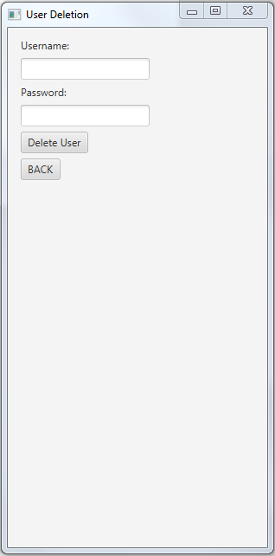

**Add Budget**

This is the user interface for the add budget button.

Here you can select one of the weekly, monthly, yearly options for budgets.

After that you can enter your budget name for your budget.

And then you can enter the username the budget belongs to.

The submit button sends the data to the database and clears all fields. The clear button clears all fields for easy clears. And the back button closes the window.

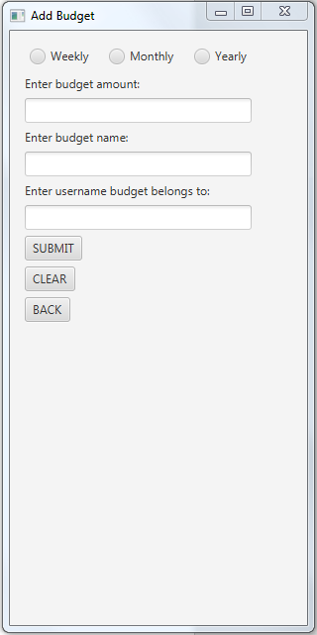

**Add Item**

This is the user interface for the add item button. This is to add an item to a budget that belongs to a user.

You can add item name, price, quantity, purchase date, the budget the item belongs to, and category.

Submit adds the item to the database. Clear clears the fields. And back closes the window.

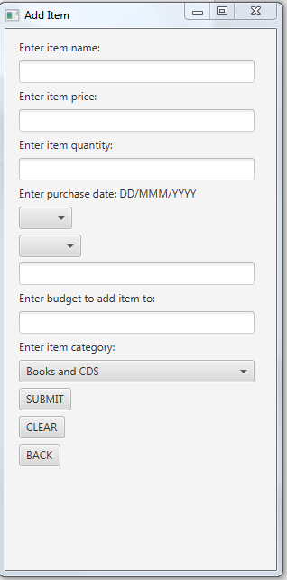

**Create user table**

**Describes all fields for the Mj_user table**

|  |  |
| --- | --- |
| Field | Description |
| userId | A unique id for each user. Doesn’t require the user to enter input. |
| userName | The username that defines a user. |
| Password | A password that relates to the username. |
| FirstName | The first name of the user. |
| LastName | The last name of the user. |
| budgetAmount | The amount you want to budget. The budgets you create will check that they don’t go over this amount when added. Must be a number. |
| incomeAmount | The amount of income the user makes. This is used for calculations. Must be a number |
| savingsAmount | The amount of savings the user has in a savings account. This is used for calculations. Must be a number |
| numberOfBankAccounts | The number of bank accounts the user has. Must be a number |
| bankAccountTotal | The total amount in all bank accounts of a user. Must be a number |

**Add budget table**

**Describes all fields for the Mj_budget table**

|  |  |
| --- | --- |
| Field | Description |
| budgetId | A unique id for each budget. Entered automatically |
| budgetType | Three options between monthly, weekly, yearly. Represents the types of budgets you can make. |
| budgetName | The name of the budget. |
| userId | The user id from the Mj_user table. Relates the two tables. Entered by using username of the person the budget belongs to. |
| budgetAmount | The amount to budget. |
| budgetTotal | The budget total that is checked against budget amount when an item is added. |
| overBudget | A true, false for if the budget is overbudget or underbudget. Used to check if adding an item to a budget is okay. Default false. |

**Add item table**

**Describes all fields for the Mj_item table**

|  |  |
| --- | --- |
| Field | Description |
| itemId | A unique id for each item. Entered automatically. |
| itemName | The name of the item to be added. |
| itemType | The type of item to be added the drop down menu contains all categories. |
| itemPrice | The price of the item to be added. Cannot be negative |
| itemQuantity | The quantity of the item you want to add. For example two candy bars. Cannot be negative. |
| purchaseDate | The purchase date of the item to be added. Cannot be negative |
| budgetId | BudgetId from the Mj_budget table. Relates the two tables. This is entered by using the budget name the item belongs to. |